***Project Management Methodologies***

**Smart Wheel Chair**

## **Smart Wheelchair (SW) is a new concept aiming to allow higher autonomy to people with lower mobility such as disabled or elderly individuals. Some of the more recent SW’s have a multimodal interface, enabling multiple command modes such as joystick, voice commands, head movements, or even facial expressions. In these SW it may be very useful to provide the user with the best way of driving it through an adaptive interface. This paper describes the foundations for creating a simple methodology for extracting user profiles, which can be used to adequately select the best SW command mode for each user. The methodology is based on an interactive wizard composed by a flexible set of simple tasks presented to the user, and a method for extracting and analyzing the user’s execution of those tasks. The results achieved showed that it is possible to extract simple user profiles, using the proposed method. Thus, the approach may be further used to extract more complete user profiles, just by extending the set of tasks used, enabling the adaptation of the SW interface to each user’s characteristics.**

**INTRODUCTION:**

The fraction of population with physical disabilities has earned more relevance and has attracted the attention of international health care organizations, universities and companies interested in developing and adapting new products. The actual tendency rehabilitation services, in a way that senior and handicapped individuals might become more and more independent performing quotidian tasks. Regardless the age, mobility is a fundamental characteristic for every human being. Children with disabilities are very often deprived of important opportunities and face serious disadvantages compared to other children. Adults who lose their independent means of locomotion become less self sufficient, raising a negative attitude towards them. The loss of mobility originates obstacles that reduce the personal and vocational objectives. Therefore it is necessary to develop technologies that can aid this population group, in a way to assure the comfort and independence of the elderly and handicapped people.

**AIMS AND OBJECTIVE:**

We were looking at a problem that disable population faces. Noticing that the disabled people all around the world get very little attention, we decided to aim our project towards them in order to help as much as we can. Our influence might end up being minimal, but remember that a ten kilometer walk starts with a small step. Disabled people rely heavily on their wheelchairs for transportation. The wheelchair frees them from their burdens and constraints and provides them with mobility. It has become a necessity to all, such that they cannot live without it anymore. For all these reasons, and in order to start a change, we decided to concentrate our effort on pinpointing the weaknesses in wheelchairs and improving them as much as we can. Our project will mainly feature one major idea in accordance with a few minor ones.  The major idea that we will be trying to implement is to introduce the smart wheelchair for the first time. By smart we mean that the wheelchair will be controlled by two sources, Speech (voice control), and hand movement. This major idea tends to solve the main problem faced by the persons with limb disabilities, who can’t propel the wheel chair by themselves and they require some other source of control which is based on human sensing abilities. For these we need to use intelligent programming algorithms for controlling different sensors. This will make wheelchair an autonomous vehicle with smartness.

## **COMMUNICATION INTERFACE:**

Smart wheelchair is generally equipped with sensors, cameras and computer-based system as main processing unit to be able to perform specific task. smart wheelchairs are controlled by human user interface where the human makes decisions at the highest level of operation and the smart control technology makes the rest of the motion automatic.But at the same time we have some disadvantage is that it can,t work in noise environemt , it can only understand English at the same time it have some distance which it will work on it, otherwise a long distance from user to wheel chair make some sort for the user.

## **HAND GESTURE CONTROL:**

This project is to develop a wheel chair for physically disable people.The wheel chair is controlled by hand movement/hand gestures. The gestures are recognized by an accelerometer sensor. The flex sensor is used to controlled by speed by moving fingures. Accelerometer sensor is used to recognize the hand gestures. It recognize the acceleration (tilting) of the hand in both X and Y-axes.It produces different numerical values corresponding to the different of acceleration accelerometer.

**VOICE CONTROLLED:**

Speech recognition is a popular topic in today’s life. The applications of Speech recognition can be found

Speech recognition is a popular topic in today’s life. The applications of Speech recognition can be foundeverywhere, which make our life more effective. For example the applications in the mobile phone, instead of typing the name of the person who people want to call, people can just directly speak the name of the person to the mobile phone, and the mobile phone will automatically call that person. If people want send some text messages to someone, people can also speak messages to the mobile phone instead of typing.

The main objective of VOICE CONTROLLED WHEEL CHAIR SYSTEM project is recommended to control a wheel chair by using speech recognition module. The system is designed to control a wheel chair using the voice of person. The objective of this project is to fascilate the movement of people who are disable or handicapped and elderly people who are not able to move well. The user can control the wheelchair by **voice commands**, such as “FORWARD” the wheel chair will move forward , “BACKWARD” the wheel chair will move backward , “LEFT” , wheel chair turn to left side , “RIGHT” , the wheel chair will move right side , and the last command “STOP” the wheel chair will stop.

**HARDWARE USED:**

* Gyro Scope Sensor
* Accelerometer sensor
* Flex Sensor
* Arduino Uno
* L298N Module
* Bluetooth Module HC-05
* DC motor
* Arduino nano
* Adxl 345 or mpu 6050
* Jumper cable

**Description of Hardware:**

**Gyro Scope Sensor:**

**What is the use of gyroscope sensor in mobile phones?**

This saves both battery life and prevents accidental screen touches. Accelerometers in mobile phones are used to detect the orientation of the phone. The gyroscope, or gyro for short, adds an additional dimension to the information supplied by the accelerometer by tracking rotation or twist.

**Accelerometer sensor:**

**What is the use of accelerometer sensor?**

An accelerometer is an electromechanical device used to measure acceleration forces. Such forces may be static, like the continuous force of gravity or, as is the case with many mobile devices, dynamic to sense movement or vibrations. Acceleration is the measurement of the change in velocity, or speed divided by time.

**How does an accelerometer measure vibration?**

Vibration is most commonly measured using a ceramic piezoelectric sensor or accelerometer. The benefits of an accelerometer include linearity over a wide frequency range and a large dynamic range. Accelerometers are versatile sensors used for high or low frequency vibration as well as shock measurements.

**Can an accelerometer measure speed?**

The sensor in itself can't provide you the velocity. I have used it accelerometers in a couple of projects the easiest way to get the velocity is to constantly monitor acceleration changes and calculate velocity instantaneaously. .The sensor will provide you value of acceleration at any given time.

**Flex Sensor:**

**What is the output of flex sensor?**

Flex sensor. The Flex Sensor is a unique component that changes resistance when bent. An unflexed sensor has a nominal resistance of 10,000 ohms (10 K). As the flex sensor is bent the resistance gradually increases.

**How does flex sensor work?**

As a variable printed resistor, the Flex Sensor achieves great form-factor on a thin flexible substrate. When the substrate is bent, the sensor produces a resistance output correlated to the bend radius—the smaller the radius, the higher the resistance value.

**Arduino Uno:**

**How does the Arduino work?**

The Arduino board is connected to a computer via USB, where it connects with theArduino development environment (IDE). The user writes the Arduino code in the IDE, then uploads it to the microcontroller which executes the code, interacting with inputs and outputs such as sensors, motors, and lights.

**Adxl 345:**

**How does accelerometer adxl335 works?**

By measuring the amount of acceleration due to gravity, an accelerometer canfigure out the angle it is tilted at with respect to the earth. ... ADXL335 is 3 axisaccelerometer with on board voltage regulator IC and signal conditioned Analog voltage output. The module is made up of ADXL335 from Analog Devices.

**Arduino Nano:**

Arduino Nano is a surface mount breadboard embedded version with integrated USB. It is a smallest, complete, and breadboard friendly. It has everything that Diecimila/Duemilanove has (electrically) with more analog input pins and onboard +5V AREF jumper.

Arduino Uno is a very valuable addition in the electronics that consists of USB interface, 14 digital I/O pins, 6 analog pins, and Atmega328 microcontroller. It also supports serial communication using Tx and Rx pins.

The software used for Arduino devices is called IDE (Integrated Development Environment) which is free to use and required some basic skills to learn it. It can be programmed using C and C++ language.

**L298N Module:**

**How does the l298n work?**

The L298N is a dual H-Bridge motor driver which allows speed and direction control of two DC motors at the same time. The module can drive DC motors that have voltages between 5 and 35V, with a peak current up to 2A. Let's take a closer look at the pinout of L298N module and explain how it works.

**Bluetooth Module HC-05:**

**What is the range of HC 05 Bluetooth module?**

The HC-05 module can reach a range of up to 9 meters (30 ft). If you need a Bluetooth module to talk to your smartphone and an Arduino board, the HC-05 would work fine.

**Can Bluetooth go through walls?**

Most Bluetooth devices, especially those that run on battery power, are Class 2 Bluetooth devices. Class 2 devices have a range of about 10 meters, or around 30 feet. ... While the Bluetooth signal will work through walls, the more objects that are in between the devices, the less overall range the devices will have.

**MPU 6050:**

**What MPU 6050?**

The MPU 6050 is a 6 DOF (degrees of freedom) or a six-axis IMU sensor, which means that it gives six values as output: three values from the accelerometer and three from the gyroscope. The MPU 6050 is a sensor based on MEMS (micro electro mechanical systems) technology.

**CODING:**

**VOICE CONTROL**

**In python:**

**We are using speech recognition and web browser as in our as a built-in libaray.**

**HAND GESTURE**

**In C++ :**

**We are using**

ADXL345_DEVID 0x00

ADXL345_RESERVED1 0x01

ADXL345_THRESH_TAP 0x1d

ADXL345_OFSX 0x1e

ADXL345_OFSY 0x1f

ADXL345_OFSZ 0x20

ADXL345_DUR 0x21

ADXL345_LATENT 0x22

ADXL345_WINDOW 0x23

ADXL345_THRESH_ACT 0x24

ADXL345_THRESH_INACT 0x25

ADXL345_TIME_INACT 0x26

ADXL345_ACT_INACT_CTL 0x27

ADXL345_THRESH_FF 0x28

ADXL345_TIME_FF 0x29

ADXL345_TAP_AXES 0x2a

ADXL345_ACT_TAP_STATUS 0x2b

**HOW OUR PROJECT IS WORKING….**

**VOICE CONTROL DIAGRAM**

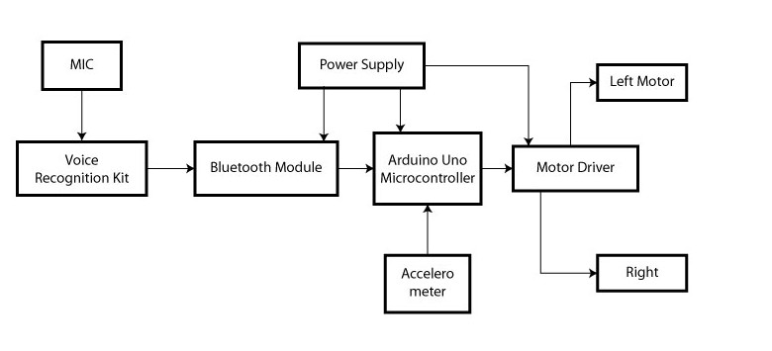

**____________________________________________________________**

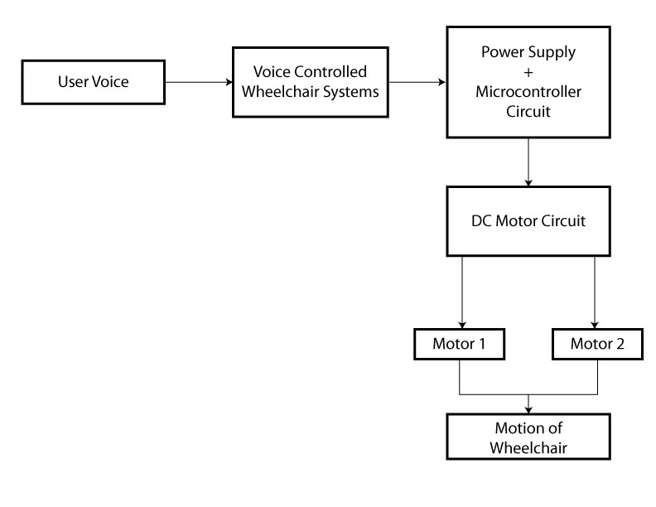

**HAND GESTURE DIGRAM**

